In this chapter, we'll define machine learning and its relation to data science and artificial intelligence. Then, we'll unpack important machine learning jargon and end with the machine learning workflow for building models.

**1. What is machine learning?**

Welcome to Machine Learning for Everyone! I'm Lis and I'll be one of your guides in demystifying machine learning.

**2. Headlines**

You've probably heard the terms machine learning and artificial intelligence in media. Perhaps, how machine learning algorithms have beaten humans at complex games like chess, GO, and StarCraft.

**3. Headlines**

Or, the way machine learning and artificial intelligence can be used to provide better medical diagnoses and treatments.

**4. Headlines**

Or, that you're using technology with machine learning daily, from intelligent assistants to different apps on your phone.

**5. Headlines**

Artificial intelligence is impacting a diverse range of domains, such as medicine, marketing, HR, and even art!

**6. Headlines**

From self-driving cars to believable fakes, artificial intelligence and machine learning have implications for the future of our society and how we function.

**7. Headlines**

That's why there's been so much investment in researching artificial intelligence and even providing education on artificial intelligence. So what does artificial intelligence and machine learning mean exactly? And how do they relate?

**8. Artificial intelligence (AI)**

First, let's talk about artificial intelligence or AI. Today, when people refer to AI, they're most likely referring to machine learning AI is a huge set of tools for making computers behave intelligently. It comprises of several sub-fields, including robotics and machine learning.

**9. Artificial intelligence (AI)**

In recent decades, machine learning has become the most prevalent subset of AI.

**10. Defining machine learning:**

Defining machine learning is not simple. Machine learning has many applications and overlaps with several other fields. Combined with the rapid growth of machine learning as a field, the boundaries of machine learning can be blurry. We like to define machine learning as a set of tools for making inferences and predictions from data. Let's compare inference and prediction tasks to better understand what machine learning can do.

**11. Defining machine learning: what can it do?**

Prediction is about the outcome of future events. For example, will it rain tomorrow? Inference is more vague because it's about drawing insights. We can infer the causes of events and behaviors, for example, why it rains. We may get a combination of factors like the month, humidity, and temperature. We can also infer patterns, for instance, what are the different types of weather conditions? Such as a rain or overcast. Ultimately, these tasks can work together, because inferences help make predictions, however they require different types of machine learning.

**12. Defining machine learning: how does it work?**

So, how does it all work? Machine learning methods are taken primarily from statistics and computer science. Machine learning is extremely powerful because it gives computers the ability to learn without being explicitly programmed to do so. Meaning, the computer can learn without step-by-step instructions. Essentially, machine learning learns patterns from existing data and applies it to new data. For example, it can process archived emails to learn what spam looks like on its own. Then, using what it learned, it can detect spam in new emails. For machine learning to be successful, it needs high-quality data. We'll be learning more about all this as we move through the course!

**13. Data science**

With all this data talk, you may be wondering: where does data science fit? Data science is about discovering and communicating insights from data.

**14. Data science**

Machine learning is often an important tool for data science work, especially for making predictions from data.

**15. Machine learning model**

We've defined machine learning, but what does it look like in practice? The answer is machine learning models. A machine learning model is a statistical representation of a real-world process, like how we recognize cats or hourly changes in traffic. A process is modeled using data.

**16. Machine learning model**

We can enter new inputs into a model to get an outcome.

**17. Machine learning model**

For example, if we make a model based on historical traffic data, we can enter a future date into the model to predict how heavy traffic will be tomorrow afternoon.

**18. Machine learning model**

The output can even be the probability of an outcome, for example, the probability that a tweet is fake. In this course, we'll unveil the "black box" that is the model.

**19. Let's practice!**

Alright, it's time for your first exercises!

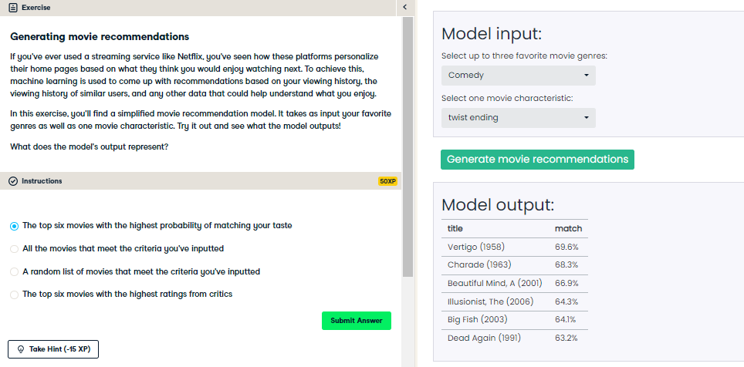

Nice! Did our model do a good job of recommending movies to you? Throughout this course, you'll learn more about what's happening in the 'black box': how is a model actually generate these outputs? Stay tuned!

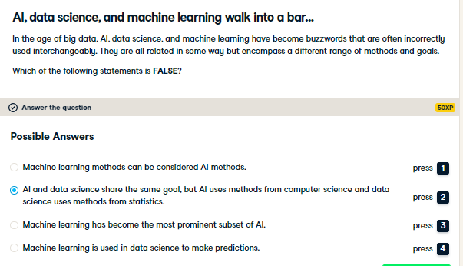

Nice! AI and data science do not share the same goal. AI is concerned with intelligence in computers, while data science is about using data for insights. However, there is overlap, it's usually machine learning!

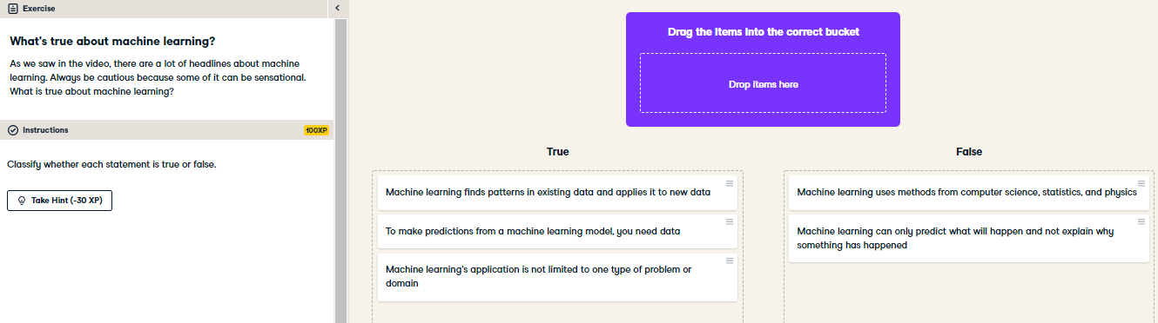

Nice job! As we get deeper into this course, you'll be able to explain in more depth why these statements are true or false!